Q1
(a) Is there a significant relationship between age and photograph preference?
Use the Chi-Square Test of Independence.
Hypotheses
- H₀: Age and photograph preference are independent.
- H₁: Age and photograph preference are associated.
Observed Table:
Age | A | B | C
5–6 | 18 | 22 | 20
7–8 | 2 | 28 | 40
9–10 | 20 | 10 | 40
After performing the Chi-Square test:
- χ² ≈ 20.36
- Degrees of Freedom = 4
- p-value < 0.05
Conclusion: Reject H₀. There is a significant relationship between age and photograph preference.
What is wrong with this study?
- Sample size is small.
- Selection method is not mentioned.
- Only three photographs are used, causing possible bias.
- Other factors (gender, background, culture) are ignored.
Sample R Code
A<-c(18,2,20)
B<-c(22,28,10)
C<-c(20,40,40)

cov(B,C)
cov(cbind(A,B,C))
cor(B,C)
cor(cbind(A,B,C))

output:
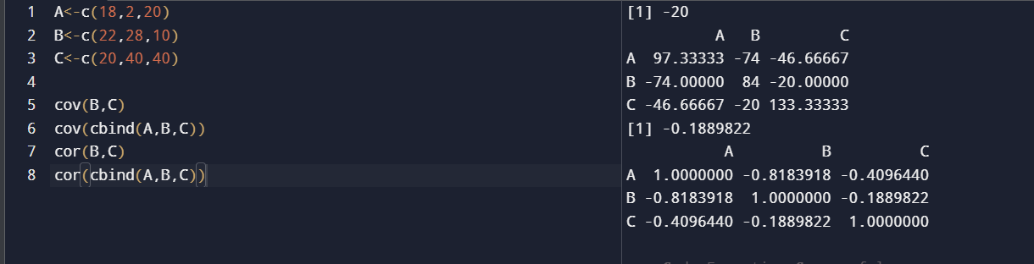

Q2
Box Plot for Tennis Scores
Scores:
12, 15, 14, 10, 18, 20, 22, 13, 11, 35, 16, 17, 19, 21, 23
R Code
points<-c(12,15,14,10,18,20,22,13,11,35,16,17,19,21,23)

boxplot(points,
main="Tennis Players Points",
ylab="Points",
col="lightblue")
output:

Inference
- Median ≈ 17
- Most scores lie between 13 and 21
- 35 appears as an outlier
- The distribution is positively skewed because of the high outlier.

Q3
Decision Tree for Loan Approval
Dataset features:
- Age
- Income
- Employment Status
- Credit Score
Target:
- Loan Approval (Yes/No)
R Code
library(rpart)
library(rpart.plot)

loan<-read.csv("loan.csv")

model<-rpart(Loan~Age+Income+Employment+CreditScore,
data=loan,
method="class")

rpart.plot(model)

predict(model,type="class")
Output:
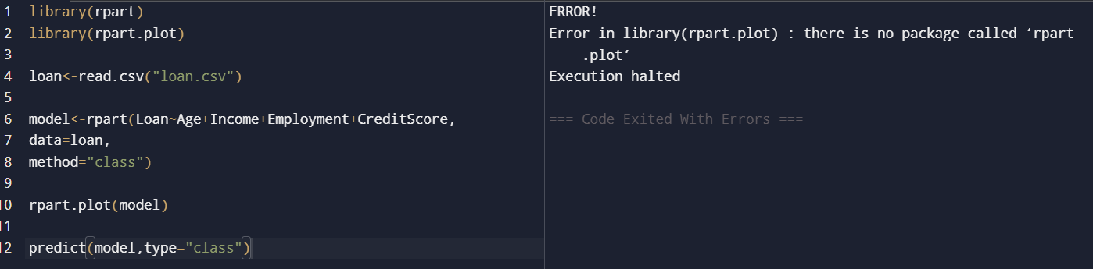
Decision Tree Rules
- Good credit + employed → Approve
- Poor credit + unemployed → Reject
- Medium income + good credit → Approve
- Low income + poor credit → Reject
Conclusion: The Decision Tree effectively classifies loan approval based on customer attributes.

Q4
Class A
76, 35, 47, 64, 95, 66, 89, 36, 84
- Mean = 65.78
- Median = 66
- Range = 60
Class B
51, 56, 84, 60, 59, 70, 63, 66, 50
- Mean = 62.11
- Median = 60
- Range = 34
Conclusion
- Higher Mean: Class A
- Higher Median: Class A
- Greater Range: Class A
R Code
A<-c(76,35,47,64,95,66,89,36,84)
B<-c(51,56,84,60,59,70,63,66,50)

mean(A)
median(A)
max(A)-min(A)

mean(B)
median(B)
max(B)-min(B)

boxplot(A,B,
names=c("Class A","Class B"),
col=c("lightblue","pink"))
Output:
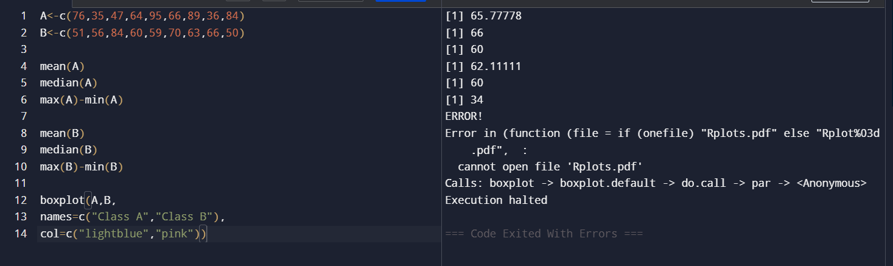
Inference
- Class A scored higher overall.
- Class A has more variation.
- Class B scores are more consistent.

Q5
Age Data
23,25,27,27,39,41,47,49,50,52,54,54,56,57,58,58,60,61
% Fat Data
9.5,26.5,7.8,17.8,31.4,25.9,27.4,27.2,31.2,34.6,42.5,28.8,33.4,30.2,34.1,32.9,41.2,35.7
Results
Measure | Age | % Fat
Mean | 46.00 | 28.01
Median | 51.00 | 29.50
Standard Deviation | 13.45 | 9.49
R Code
age<-c(23,25,27,27,39,41,47,49,50,52,54,54,56,57,58,58,60,61)

fat<-c(9.5,26.5,7.8,17.8,31.4,25.9,27.4,27.2,31.2,34.6,42.5,28.8,33.4,30.2,34.1,32.9,41.2,35.7)

mean(age)
median(age)
sd(age)

mean(fat)
median(fat)
sd(fat)

boxplot(age)
boxplot(fat)

plot(age,fat,
main="Age vs Body Fat",
xlab="Age",
ylab="% Fat")

qqnorm(age)
qqline(age)

qqnorm(fat)
qqline(fat)
Output:
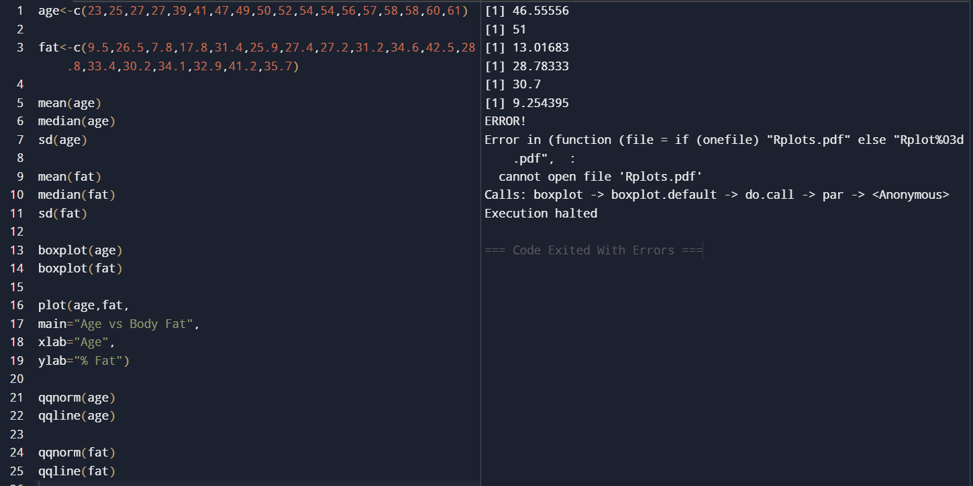
Inference
- Age and body fat generally increase together.
- No major outliers are observed.
- Scatter plot indicates a positive relationship.
- Q-Q plots show the data are approximately normally distributed.

